**Secondary Ion Mass Spectrometer**

**Preliminary Report**

**Sharna Beahm**

**Isaiah Cons**

**Riley Ducey**

**Ben Hardesty**

**Fall 2016**

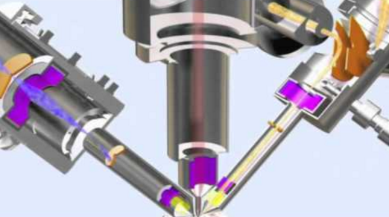

**Project Sponsor: Dr. Michael V. Lee**

**Faculty Advisor: Dr. Sarah Oman**

**Sponsor Mentor: Dr. Michael V. Lee**

**Instructor: Dr. Sarah Oman**

# DISCLAIMER

This report was prepared by students as part of a university course requirement. While considerable effort has been put into the project, it is not the work of licensed engineers and has not undergone the extensive verification that is common in the profession. The information, data, conclusions, and content of this report should not be relied on or utilized without thorough, independent testing and verification. University faculty members may have been associated with this project as advisors, sponsors, or course instructors, but as such they are not responsible for the accuracy of results or conclusions.

# TABLE OF CONTENTS

DISCLAIMER ……………………………………………………………………………………………..ii

TABLE OF CONTENTS iii

1 BACKGROUND 1

1.1 Introduction 1

1.2 Project Description 1

1.2.1 Original Proposal 1

1.2.2 Updated Proposal 2

1.3 Original System 2

2 REQUIREMENTS 3

2.1 Customer Requirements (CRs) 3

2.2 Engineering Requirements (ERs) 3

2.3 Testing Procedures (TPs) 4

2.4 Design Links (DLs) 4

2.5 House of Quality (HoQ) 5

3 EXISTING DESIGNS 7

3.1 Design Research 7

3.2 System Level 7

3.2.1 Existing Design #1: Secondary Ion Measurement with Time of Flight (TOF) 7

3.2.2 Existing Design #2: Secondary Ion Measurement with Mass Spectrometer 8

3.2.3 Existing Design #3: Secondary Ion Measurement with Phosphor Plate 8

3.3 Subsystem Level 8

3.3.1 Subsystem #1: Vacuum Chamber Design 8

3.3.1.1 Existing Design #1: Spherical Vacuum Chamber 8

3.3.1.2 Existing Design #2: Rectangular Prism Vacuum Chamber 9

3.3.1.3 Existing Design #3: Custom Engineered Vacuum Chamber 9

3.3.2 Subsystem #2: Organic Electronics Sample Holder 9

3.3.2.1 Existing Design #1: Stationary Sample Holder 9

3.3.2.2 Existing Design #2: Z Axis Travel Sample Holder 9

3.3.2.3 Existing Design #3: X Y and Z Axes Travel and/or Rotating Sample Holder 9

3.3.3 Subsystem #3: SIMS Accessories 10

3.3.3.1 Existing Design #1: Chamber Baking System 10

3.3.3.2 Existing Design #2: Chamber Viewport 10

3.3.3.3 Existing Design #3: Sputter Gun or Camera Mounting Port 10

Functional Decomposition 11

4 DESIGNS CONSIDERED 12

4.1 Design #1: Vertical Orientation of Vacuum Chamber 12

4.2 Design #2: Horizontal Orientation of Vacuum Chamber 12

4.3 Design #3: Angled Sample 13

4.4 Design #4: Triangular/Hexagonal Orientation of Vacuum Chamber 13

4.5 Design #5: Cylindrical Vacuum with Cap 13

4.6 Design #6: Casting Polymer Vacuum Chamber 14

4.7 Design #7: Casting Aluminum Vacuum Chamber 14

4.8 Design #8: 3D Metal Printing Vacuum Chamber 14

5 DESIGN SELECTED 15

1. Rationale for Design Selection 15

5.1 Design Description 16

5.1.1 Internal Chamber Design 16

5.1.2 Ion Gun Placement 18

5.1.3 Pumping Time Calculation 18

5.1.4 Ion Gun and Extractor Alignment 19

6 PENDING DESIGN SELECTED 21

7 REFERENCES 22

8 APPENDICES 23

# BACKGROUND

## Introduction

A Secondary Ion Mass Spectrometer is a tool used by scientists and researchers to analyze the surface of a material. A single ion beam is shot at the surface of the material and in the collision of the ion beam and surface, secondary ions are released [1]. The mass spectrometer then collects the secondary ions using different electrical potentials to attract the ions. The mass spectrometer then analyzes the ions using their mass to charge ratios to determine different properties and characteristics of the material. Secondary Ion Mass Spectrometers, also known as SIMS, are expensive and complex and therefore most SIMS devices are built in-house. The objectives of this project are to design an ultra-high vacuum chamber (UHV), align an ion beam and ion extractor to the same spot on a sample material and develop a spectrum using a TOF spectrometry instrument. Dr. Michael V. Lee, our sponsor for this project, is an assistant professor and analytical chemist at Northern Arizona University researching organic electronics and photovoltaic cells. A SIMS device will give Dr. Lee the ability to precisely analyze the organic electronic material in hopes to slow the decay rate. The organic electronic would then lower the cost of photovoltaic cells making renewable solar energy more cost effective and available to the public. The SIMS device, outside of Dr. Lee's research, would also be available to other programs at Northern Arizona University to analyze a material to better understand the materials potential applications. The engineering program could use the mass spectrometer for environmental, petroleum and biological analysis along with some applications into genetic engineering.

## Project Description

### Original Proposal

The original project description, as provided by our client, is as follows:

Secondary ion mass spectrometry (SIMS) uses one ion beam to bombard a surface. The ions are accelerated with high potential, usually on the order of kV, toward a sample surface. When the ions strike the surface, they penetrate a few nanometers into the sample and eject or sputter off material from the sample. All of the material is small molecules or single atoms and some of them carry a charge. A separate pole piece uses a potential to collect the ions (either positive or negative ions) and accelerate them into a mass spectrometer. The mass spectrometer identifies the ions by mass (technically mass-to-charge ratio). The spectrum of the different ions that were sputtered gives a chemical fingerprint of the sample surface. Rastering the beam can then provide a chemical map of the surface. SIMS acts as a chemical microscope imaging the chemical nature of a surface with spatial resolution that can reach even 50 nm.

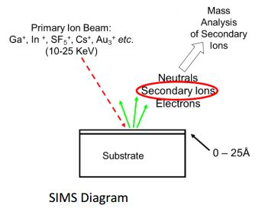

Figure 1A: SIMS Diagram

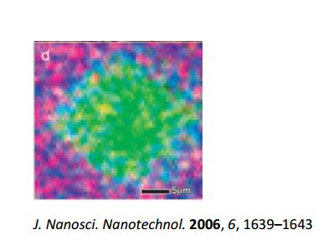

Figure 1B: Focus of Ion Gun and TOF

The SIMS system is composed primarily of a primary ion gun and an ion extractor that connects to the mass spectrometer, sealed in an ultra-high vacuum (UHV) system (~ ${10}^{-8}torr$). For this project, a Cs+ ion gun and a refurbished triple quadrupole mass spectrometer will be integrated onto a custom vacuum chamber pumped with a turbo pump.

The tasks required for the overall design project include:

1. Design a custom UHV system with proper structure, flanges, and angles to align an ion beam, and ion extractor to the same spot on a sample. The distance from the gun to the sample and the extractor to the sample also need to be appropriately defined. The design should account for baking, as well as required vacuum gauges, venting, and later addition of sputter gun for the depth profiling. The design should also account for the weight of the additional parts of the system.

Estimate student involvement: 2-3 ME capstone students.

Budget for fabrication of customized chamber: TBD

1. Design a custom UHV enclosure for the triple-quadrupole mass spectrometer that integrates with the main UHV system. Design should minimize the required vacuum pumping required and determine appropriate pumping needs, accounting for needs of both the viscous flow and molecular flow regimes. The group should also design a testing mechanism for the mass spectrometer under UHV to ensure proper operation.

Estimate student involvement: 3 ME and 3 EE for design of the enclosure and of the testing system, including control of all electrodes while maintaining shielding and isolation; 3 CS for design of functions for controlling each piece of the mass spectrometer, as well as main program to test the components using the test system.

### Updated Proposal

The goal of the previous proposal involved a system that was usable and improvable for future projects. Our client has decided to change the purpose of the instrument and wants the team to focus solely on getting a spectrum. As previously stated the project was initially to be a capstone project for multiple years, and has since been scheduled to be done within one year’s capstone. Rather than just focusing on mechanical aspects, electrical must also be factored in.

Due to the change in scope, the mass spectrometer is no longer ideal for the system. The first reason is that it is not in working condition and is unable to be repaired by anyone but a professional. The second reason is that a mass spectrometer is not the best for getting a spectrum. A Time of Flight (TOF) Mass Spectrometer will be used instead.

## Original System

This project involved the design of a completely new Secondary Ion Mass Spectrometer. There was no original system when this project began.

# REQUIREMENTS

The requirements for this project will tell the team what the goals to achieve are which is achieving a spectrum in a Secondary Ion Mass Spectrometer instrument for this specific project. The requirements can also provide a good understanding on which parameters that can be adjusted and simplified. This section will cover what the team decided would make for effective customer and engineering requirements as well as analyzing those different criteria.

## Customer Requirements (CRs)

The CRs received from the client were based on the design requirements specified in the brief introduction to the project as well as in the first meeting with the client. From these design requirement, the customer requirements were selected upon based on what was most critical to the system as well as what most likely could be accomplished. The customer needs generated from this collaboration were:

1. Price - The overall cost must not exceed the amount specified in the budget
2. Proof of Functionality - Proof that there is a spectrum being received
3. Safe to use - Ensuring that the operators will not be in danger
4. Compact - Limiting the volume inside the vacuum chamber
5. Precision and Accuracy - Making sure the instruments are analyzing the sample
6. Quick Preparation - The system can be pumped down within a reasonable time
7. Vapor Removal - Water vapor can be removed from the system effectively
8. Sample Alignment - The sample can be lined up with other instruments
9. Moveable - Whether it is possible to move
10. System Grounding - Making sure the system is secure to a workbench
11. Atom Focusing - Increasing the amount of readings we can get from the procedure
12. Adding Accessories - Possibility to add accessories as well as the ease
13. Innovative - How creative the team gets with their ideas
14. Viewport - There is a window to see into the chamber

The team then gave weights to the customer requirements in a way that criteria critical to the satisfaction of the client's needs receives higher values than aspects that are luxuries or unnecessary for a successful system received lower values. These rankings have been collected into a table (Appendices, Table 2).

## Engineering Requirements (ERs)

The engineering requirements (ERs) are requirements like the CR’s however they are more effective in giving quantitative and qualitative information on the needs. The ER’s could be decided on by the design team based on what best fit for the CR’s. The design team analyzed these to determine what would be effective in satisfying the need. The engineering corresponding to the different customer requirements are listed below with the same numbering:

1. Manufacturing a chamber for under $3000
2. Show that we are getting atoms to the entrance of the TOF and a reading from it.
3. Shielding for all Apparatuses
4. A spherical chamber with a diameter of 6 in.
5. Ability to Target w/in tolerance
6. Pumping to 10-7 Torr in under 30 days
7. Chamber can withstand at least 300°C
8. Reliable and easy to use securing apparatus and effective focusing translation
9. Under 80 lbs
10. At least 3 ports and mounting ports compatible with variety of accessories
11. Securing the Chamber and Base to workbench
12. The ability to focus atoms into the TOF
13. Innovative Design for Chamber and Vacuum entry
14. Able to look though Viewport without eyewear

Once the parameters have been decided on the needs can be weighted and scored based on its correlation to the customer needs. This gives the design team a good understanding on where their focus needs to be and how to best spend their budget and time.

## Testing Procedures (TPs)

The testing procedures (TPs) are methods that can be performed by the team to ensure that the final design meets all the engineering requirements that were established. The TP’s chosen by the team are mainly measurements that can be taken quantitatively once the system is built completely. Even though most of these procedures may include simple tasks to determine the effectiveness other tests may be the same as achieving our final goal that was set by the team at the beginning of the project. The tests that will be performed can be seen listed below with the same numbering to their corresponding engineering requirements.

1. Calculating the cost of the chamber
2. Phosphorus sheet in front of T.O.F. or reading for T.O.F.
3. Measuring Radiation leaving the chamber
4. Measuring Diameter of the chamber
5. Measure the spot size
6. Timing the process while checking the vacuum pressure
7. Measure temperature and inspect chamber for defects and leaks
8. Checking security of material and adjustability of sample plate
9. Weigh on Industrial Scale
10. Count the number of accessible ports
11. Testing the system to ensure it is firmly mounted
12. Measuring the number of spikes collected by the T.O.F
13. Evaluating whether it simplifies or over-complicates
14. Observe whether any energy of material escapes through window

Once all the procedures above have reached completion the team can assess whether the design aspect accomplished what is desired, and if it does not then either the engineering requirements and tolerances could be altered or the testing procedures can be specified to directly address whatever issue is relevant

## Design Links (DLs)

The Design Links are the reasoning behind correlating the customer needs to the engineering requirements. While some links may be obvious and easy to understand, other may be indirect and unambiguous. For this exact reason the design links are written out explicitly with the intent of individuals with no knowledge of the topic being able to comprehend the thinking that resulted in the final engineering requirements. Listed below are the DL’s with the same numbering as the set of customer needs and engineering requirements they correlate to.

1. We have an exact budget that we cannot exceed
2. Proof that there are ions being received at the end of the extractor just as it is entering the T.O.F.
3. Necessary for user safety, both instantly and progressively
4. Limiting the volume of the chamber will reduce the amount of time it takes to pump-down
5. This will ensure that we will be receiving ions into the extractor
6. Shortening the time, it takes to pump will increase the efficiency of the instrument
7. This will ensure the chamber can withstand high temperatures and not be compromised
8. Will allow spot areas to be aligned and possibly multiple samples in one pump-down
9. Irrelevant to use of instrument but will be more practical for installation
10. Will allow for accessories to be added in the future and ensure they are not damaged during installation
11. A system that is not stable can introduce unexpected failures
12. Focusing the ions into the T.O.F. will result in more data
13. May produce a more efficient or easier to use system
14. Will allow observation of the process

After reading the design links the necessity of the engineering requirements should be conveyed and mutually understood.

## House of Quality (HoQ)

The House of Quality (HoQ) is a tool used to compare the engineering requirements that were selected upon and the customer needs that they do not directly satisfy. The HoQ (Table 1) shows that some criteria that were easily overlooked in the customer needs are more influential on other criteria than it is to the single criteria that it was originally meant to satisfy like the price of the chamber, grounding of the system, and the effectiveness of the z-axis translation for instance. These can be seen to be the most influential criteria overall by looking at the Relative Technical Importance rankings. The correlation of the specific engineering requirements to the vague customer needs made it easy to visualize how the different criteria interact with one another. It became apparent that price, volume, and proof of functionality were highly influenced by all the other criteria and would be essential to the success of the project.

Table 1: HoQ for SIMS Design

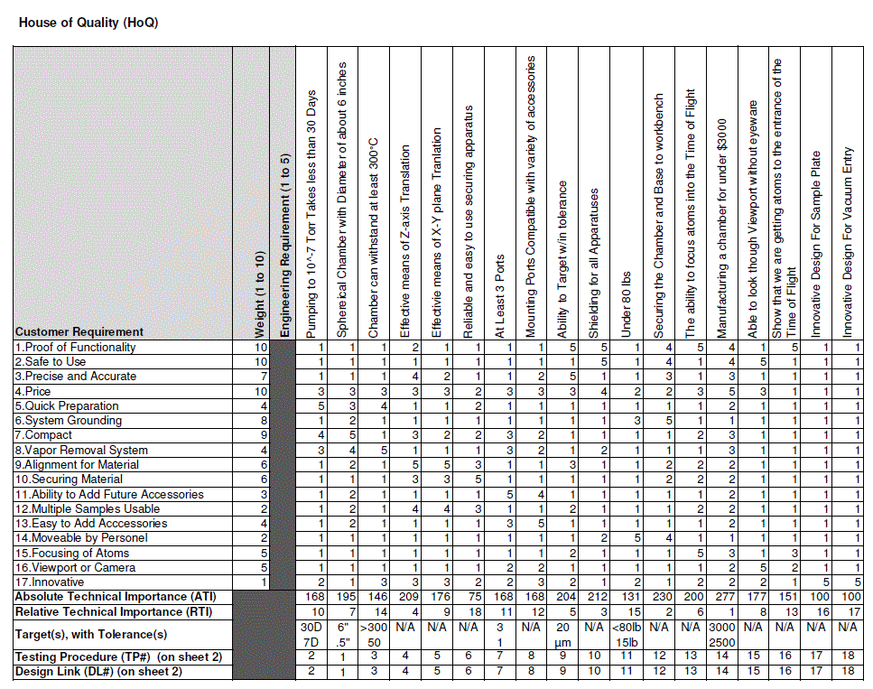

# EXISTING DESIGNS

## Design Research

It should be noted that SIMS are custom produced instruments that are built to the specification needs of the institution that implements the system. Our client, Dr. Lee, has made it known that his goal is to purchase a high precision SIMS that could potentially cost millions of dollars. The instrumentation is expensive in nature, with the cheapest ion gun priced at $40,000 [2]. Customizability and cost have led to manufacturers being restrictive of information regarding their systems. Currently, the team is in contact with Arizona State University (ASU), who already has a functioning SIMS system, and a tour of the facility is being requested [3]. Also, a manufacturer of SIMS, AZO Materials [4], has been contacted, and information about different models, prices, and implementation have been requested.   
  
The SIMS will be broken down into components that eventually will be integrated together. Each part has been researched individually and some are already available or have been ordered. The Cesium ion gun was selected [2] by our client, which he spent time thoroughly researching. His expertise and knowledge on the subject made him qualified to make this decision. The team has since researched the manufacturing specifications on the ion gun to find how to fully integrate it into the SIMS. A mass spectrometer has   
been donated to the project and, although it currently doesn't work, will be interfaced with a UHV   
chamber. Advancing to the design portion of the project will require that the specifications of the mass spectrometer are recovered. This may mean that the team will need to contact the manufacturer.   
  
Most immediately, a tour of Northern Arizona University's (NAU's) histology lab has brought some insight into the orientation and integration of a SIMS-like instrument. NAU uses a Wavelength- Disperse/Electron-Disperse Spectrometer (WDS/EDS) to identify and quantify chemical characteristics of biological samples. Like the SIMS, a WDS/EDS uses the following components to create an elemental analysis: vacuum chamber, ion source, sputtering gun, rastering, baking system, and detection. Similar requirements are needed for a SIMS design and useful information and possible design implementation was obtained when interviewing the manager of the histology lab, Aubrey Funke. For example, the WDS/EDS uses Nitrogen gas (N2) to flush the vacuum to eliminate water vapor and could be a good addition to the SIMS design. The WDS/EDS has been studied closely and in detail as a benchmark until an investigation of another SIMS can be made.

## System Level

Secondary ion mass spectrometry is a relatively common measurement technique used to reveal the composition of residing surface atoms/molecules that are otherwise a mystery. The available techniques to release and measure the surface atoms/molecules vary by application, budget, and available instrumentation. On the lower end of budget availabilities TOF, mass spectrometry, or phosphor plates are technologies that can be deployed. Each technology has advantages and disadvantages that relate to measurement accuracy, cost, and engineering effort. Quantitative versus qualitative results vary with technology and the available offerings are described below.

### Existing Design #1: Secondary Ion Measurement with Time of Flight (TOF)

TOF secondary ion measurement is a common instrumentation technique to determine atomic sources. The fundamental idea is that the amount of time an atom of unknown weight takes to travel a known distance depends on the atomic (or molecular) weight. A TOF system is advantageous in that extractors and accelerators of the secondary ions are not required however the geometry and focusing optics are complex. The resulting scientific data has lower resolution than alternatives such as mass spectrometry and the price difference is perceived to be negligible. The principal investigator in this application has requested a mass spectrometer capable SIMS [5].

### Existing Design #2: Secondary Ion Measurement with Mass Spectrometer

Measurement of secondary ions using mass spectrometry is ideal due to the combination of geometric consistencies and lack of induced error. Mass spectrometry data is widely available allowing comparison to known materials. The presently available existence of a mass spectrometer makes interface compatibility necessary however temporary attachment of other devices may prove useful in verification testing. The reigning direction of engineering effort is to be compatible with the existing mass spectrometry hardware while still being able to verify the presence of secondary ions using alternative hardware methods such as a phosphor plate. [6]

### Existing Design #3: Secondary Ion Measurement with Phosphor Plate

Photostimulated luminescence (PSL) can be used to visually detect the presence of ions. With proper geometry, the stored energy within the phosphor plate in combination with the energy from the secondary ions will emit photons visually revealing the presence of secondary ions. This scheme is the back-up for the SIMS design project as it will confirm the successful ablation of surface atoms without the added complexity of measurement equipment such as a mass spectrometer or TOF. [7]

## Subsystem Level

Laboratory instruments can vary dramatically in complexity depending on application. Many desires of scientists for the instrument’s functionality are not realistic within the budget. The balance is found with understanding what features are necessary and what others are desirable. Many options are available for SIMS devices that can add complexity to the point the device won’t fit into a standard room. SIMS components to be considered below include the vacuum chamber design, sample holder, and highly desired accessories.

### Subsystem #1: Vacuum Chamber Design

The vacuum chamber is a critical part of the SIMS in that it connects all the various components together. The chamber physically connects the ion gun, sample, and measurement device such that all air can be pumped out, provide geometric shape, and provide tolerances between components.

#### Existing Design #1: Spherical Vacuum Chamber

Spherical chambers (Fig. 2) are common and can be purchased off the shelf and may be modified for specific applications. The chamber design allows fast vacuum pumping due to the constantly changing direction of particles left in the chamber. Many extra ports can be added for accessories without considerable complications.

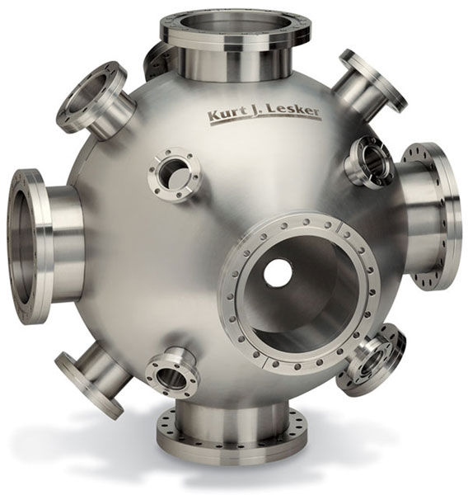

Figure 2: Kurt J. Lesker Company Spherical Chamber [8]

#### Existing Design #2: Rectangular Prism Vacuum Chamber

The main advantage of rectangular prism chambers is cost. Less engineering time is required and fabrication is more simple. This type of chamber is not ideal for every other circumstance such as long vacuum pumping times, difficulty adding accessories that are not normal to a side surface, overall size.

#### Existing Design #3: Custom Engineered Vacuum Chamber

Due to the potentially unique geometry of SIMS and the desire to minimize vacuum pumping time a custom chamber is a good option. The engineering time required is high as well as possible lead time to manufacture. Every accessory can be accommodated.

### Subsystem #2: Organic Electronics Sample Holder

The desired data output from a SIMS is the composition of the surface of a sample. The sample itself must be mechanically placed in focus of the ion source and measurement device. Other challenges include electrically grounding the surface of the sample and potentially allowing multiple samples to be tested without repumping the chamber.

#### Existing Design #1: Stationary Sample Holder

A stationary sample is the simplest option but limits the scientist in film thickness and size. The focus of the SIMS is precise and a slightly different thickness in the sample may cause the surface to be out of focus of the ion source.

#### Existing Design #2: Z Axis Travel Sample Holder

The primary motion desired in a sample holder is positioning in the Z axis to allow focus adjustment and accommodating different thicknesses of samples.

#### Existing Design #3: X Y and Z Axes Travel and/or Rotating Sample Holder

Allowing four types of motion of the sample results in the most versatile sample holder. Challenges include cost and vacuum rated motion hardware (lubrication can off gas). If multiple samples are loaded into a rotating sample holder multiple samples can be analyzed without the need to repump [9].

### Subsystem #3: SIMS Accessories

Current desired features as well as compatibility with future desired features is a very important consideration. The science goals of the SIMS will not be possible without the ability to physically attach accessories with proper geometry and tolerance.

#### Existing Design #1: Chamber Baking System

To quickly pull the pressure of the vacuum chamber from atmospheric pressure to 10^-8 Torr the chamber can be heated to approximately 150 degrees Celsius to increase the kinetic energy of remaining water vapor. The productivity of the SIMS is directly linked to this capability as pumping time is the most significant contribution of time in between sample measurements. Compatibility with baking is an important consideration from the start with surface finish specifications and CF vacuum interface fittings instead of the typical O-rings which would melt [10].

#### Existing Design #2: Chamber Viewport

Visual confirmation that the internal components of the SIMS device as well as the presence of primary ions is important for device success. Failure modes including a sample falling out of its holder and lack of primary ions can be easily diagnoses with a simple transparent viewport.

#### Existing Design #3: Sputter Gun or Camera Mounting Port

Desired future capability as discussed with Dr. Lee includes the addition of a sputter gun in conjunction with the ion source and a CCD camera. These requests require additional ports to be welded to the vacuum chamber with proper geometry and tolerances.

## Functional Decomposition

The team is designing a vacuum chamber, which is only a component of a SIMS. A functional decomposition (Fig. 3) shows a complete list of components and how they integrate. By the end of this project, all components will need to be functioning together, so it is important to design a chamber with consideration to all parts. Although the chamber is the only component being physically developed by the team, the integration of all the parts will also need to be designed including input energy sources and wiring (these aspects of design are not included in the diagram in fig. 3).

The parts that will be purchased are the Cesium Gun and TOF device. The three pumps attached to the vacuum chamber, ion gun, and TOF have been provided by our sponsor. A computer and oscilloscope will be added to the system for calculations and programming. The ion gun will secure to the vacuum chamber and release cesium ion into the chamber. A sample that is loaded into the chamber will be hit by the ions and disperse secondary ions into the chamber. The TOF device is fixed with an extractor that will also be coupled to the vacuum. The extractor will accelerate secondary ions from the chamber into the TOF device. The ions will pass through the TOF onto the detector. During this process the computer will be timing start of the pulse to the detection of ions to calculate the mass of the ion.

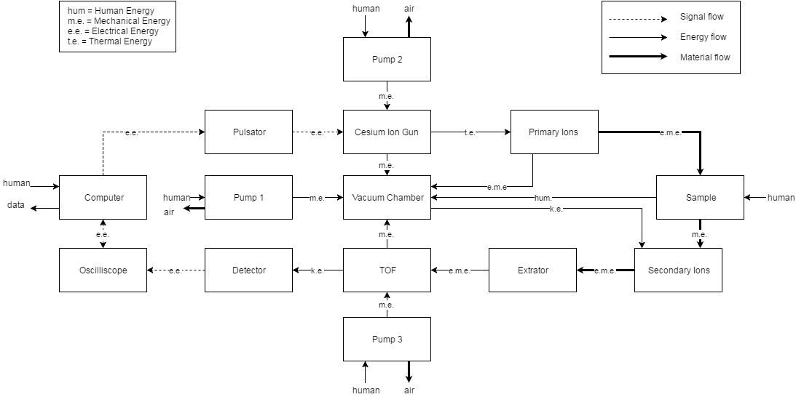

Figure 3: Functional Decomposition for SIMs

# DESIGNS CONSIDERED

## Design #1: Vertical Orientation of Vacuum Chamber

A vertical vacuum chamber (Fig. 4) is comparable to tradition chambers in aspects of size and processing. The ion gun and TOF/extractor are pointing at the same spot on the sample. This is acceptable but this orientation does not allow for the optimum angle of extraction or pulsation. Although, it makes the sample convenient to set in place and replace. This orientation can use either a cylindrical or square vacuum but a square vacuum will allow the viewing window to be installed a lot easier. A viewing window is necessary to know if the ion gun and the TOF are in line. It is also ideal if the TOF can be purposed with a laser so that when the ion gun is on, the user is able to see that the extractor is in line with the cesium spot from the ion gun.

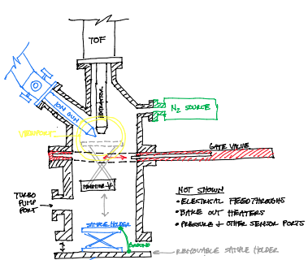

Figure 4: Welded Vertical Vacuum Chamber Design

## Design #2: Horizontal Orientation of Vacuum Chamber

A horizontal chamber design (Fig. 5) is similar to the vertical orientation, but it uses the space more efficiently. The angle between the extractor and ion gun is still not ideal.

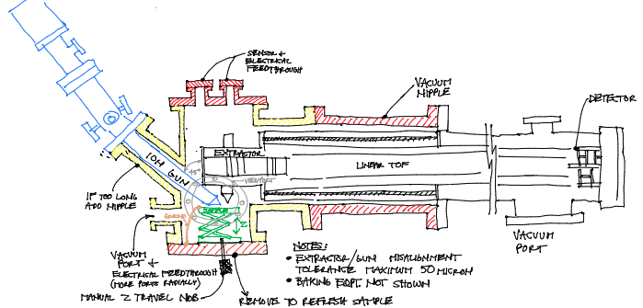

Figure 5: Welded Horizontal Vacuum Chamber Design

## Design #3: Angled Sample

This design (Fig. 6) combines the horizontal design with an angled base for the sample. This would allow the sample to be set at different angles accounting for the poor orientation of the designs above. The sample would be able to be raised until the ion gun and the extractor are in line with each other. Due to the ~45⁰ the sample would be raised until the sensors detected ions. This would decrease the need for a viewport although one is still desired. This design will be more challenging because the sample will need to be controlled from the outside and will not have a preset position. This may significantly add to the cost of the chamber.

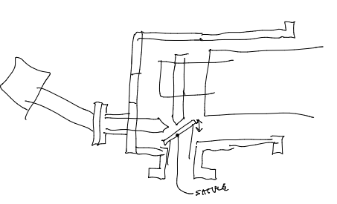

Figure 6: Horizontal Chamber with Angled Sample

## Design #4: Triangular/Hexagonal Orientation of Vacuum Chamber

A triangular design (Fig. 7) is a way to increase the strength of the chamber and make the angle between the ion gun, extractor, and sample ideal. The sides of the triangle allow the gun and TOF/extractor to be perpendicular to the vacuum wall and still be at the right angle.

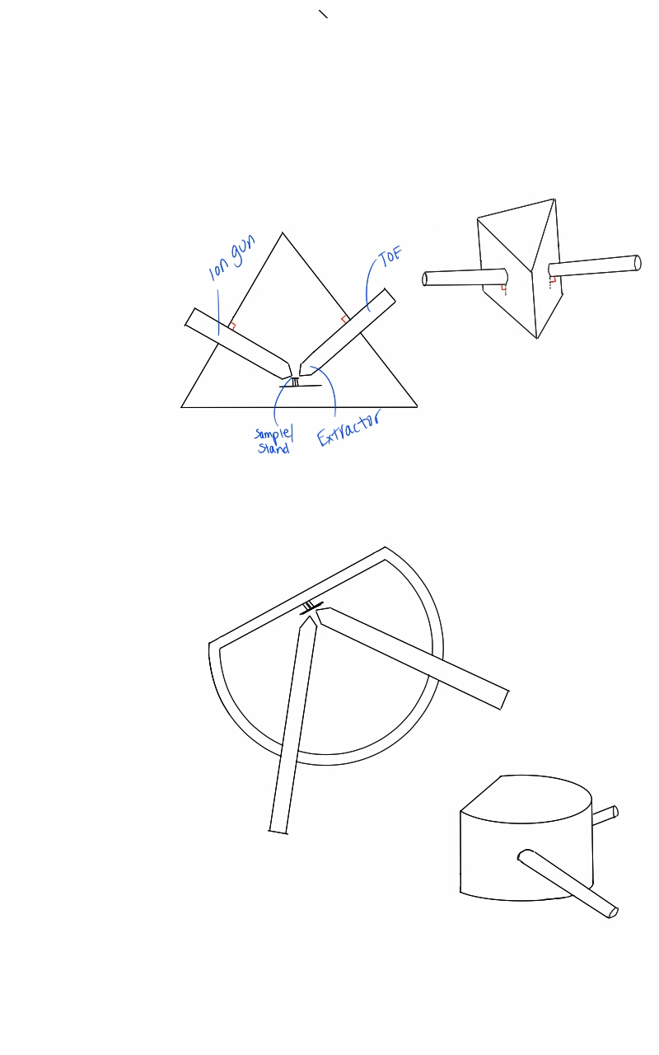

Figure 7: Triangular Vacuum Chamber (3D and cross section model)

## Design #5: Cylindrical Vacuum with Cap

This concept would repurpose a cylindrical vacuum chamber and add a cap (Fig. 8). This would allow the sample to be placed in the chamber with ease and cut down the volume of the chamber. An issue could arise with the strength of the structure when the cylinder is cut into. It is not definite that the cap will keep the walls from collapsing.

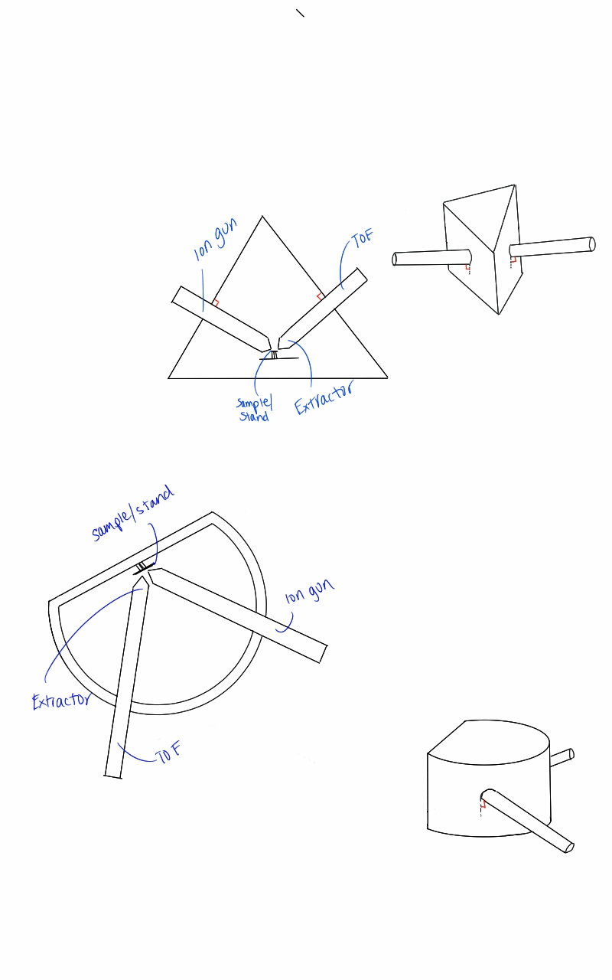

Figure 8: Cylindrical Vacuum Chamber with Cap (3D and cross section model)

## Design #6: Casting Polymer Vacuum Chamber

This will be the cheapest of all the design options. First a mold would be designed to the smallest volume possible for the system and would be 3D printed. A polymer would then be casted to make the vacuum chamber. This, to the knowledge of the team has never been done in UHV conditions.

## Design #7: Casting Aluminum Vacuum Chamber

This will allow for a custom made, cheap vacuum. It is quite feasible to make such a UHV, but the team is unsure of variables like off-gassing. The benefits are very desirable due to low cost, light weight, and strength. Issues could arise because of casting with grain, and crack variabilities that don’t occur when a vacuum is machined.

## Design #8: 3D Metal Printing Vacuum Chamber

This design would allow the chamber to be as small as possible and possibly not a conventional cylindrical or square vacuum and wrap around the ion gun and extractor. The issue is that 3D printing is notorious for large porosity which may make it impossible to hold a UHV.

# DESIGN SELECTED

After much experimentation, a traditionally fabricated vacuum chamber with a linear TOF was selected.

## Rationale for Design Selection

The traditionally fabricated vacuum chamber has both advantages and disadvantages. These can be seen in the decision matrix (Table 2). Most the chambers in the decision matrix will need to be manufactured which will increase our cost and lead time significantly. Cost and lead time is high however the percentage chance that the chamber will fail is low. Investigations into the 3D printed/aluminum casted chamber were extensively explored. The design freedom of a 3D printed chamber was highly desirable but it was determined that the chamber quality needed was not achievable. To pull a vacuum to meet minimum SIMS requirements the chamber’s internal surfaces must be very smooth [Dr. Michael V. Lee]. After multiple attempts casting test chambers an acceptable surface roughness proved impossible. See Fig. 10 for images of attempted chamber casting.

Table 2: Decision Matrix

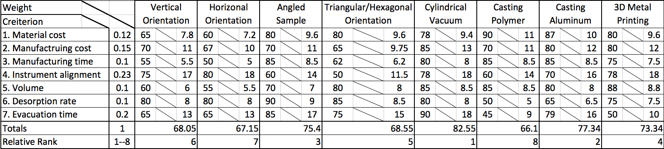

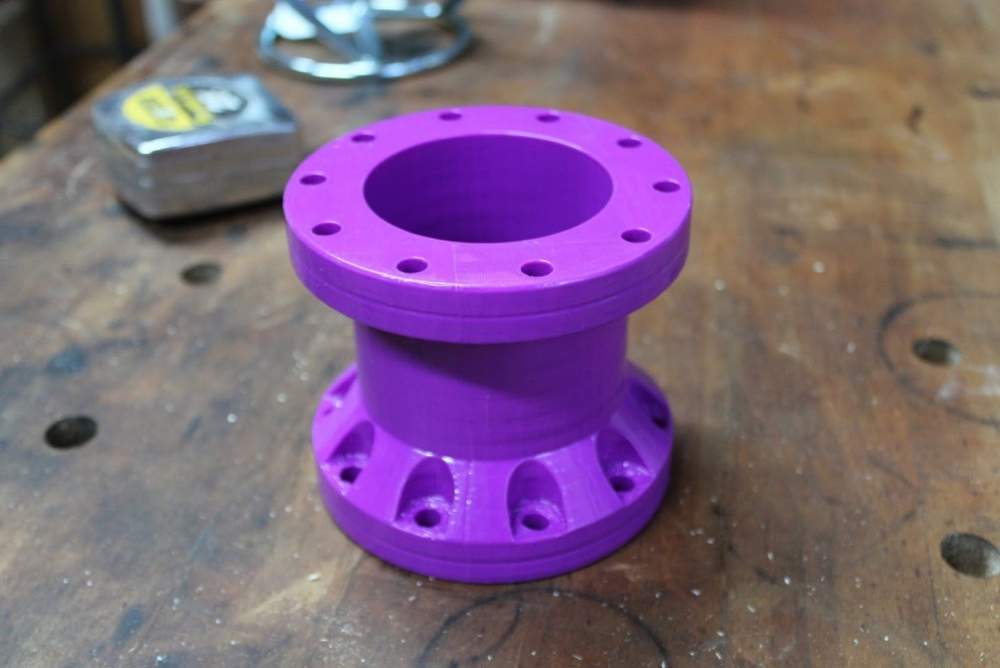

Figure 9: 3D printed test chamber. Based on 75mm CF flanges, the model was printed in ABS and acetone-vapored to achieve the smoothest surface possible.

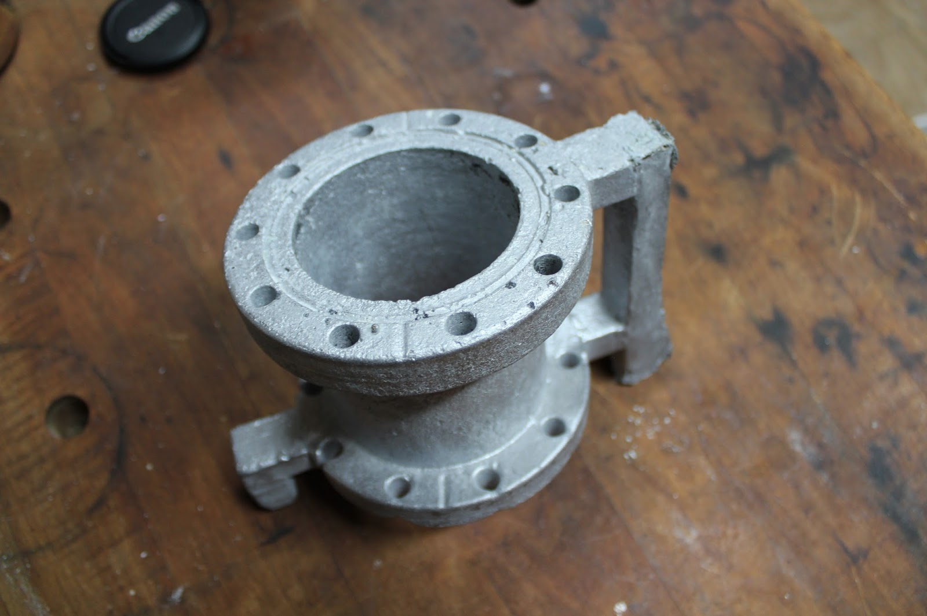

Figure 10: The resulting investment mold casting showed rough surface finish and many other defects such as porosity, contamination, and failure to completely fill the mold

After testing proved casting a chamber was not a possibility the only remaining options were a prefabricated chamber or custom made chamber. It was determined that minimal internal volume is of high priority which resulted in the decision to design and fabricate a custom chamber.

For secondary ion detection and measurement, Dr. Michael V. Lee offered the possibility of purchasing a TOF. Due to the unknown condition of the available mass spectrometer and goal of simply getting a spectrum, the TOF was highly desirable. The added cost will be significant however the chances of success are greatly improved.

## Design Description

Further description of the details of the selected design follows. The details are determined by constraints in association with the use of purchased equipment. Physical barriers with the process of a TOF/SIMS make certain geometry non-adjustable.

### Internal Chamber Design

Ideal optimization of the interior chamber would include the extractor about 35 degrees from the sample [11]. This is not ideal for this design because the ion gun would no longer be orthogonal to the TOF/extractor. For financial purposes and simplicity, the ideal settings for beam ionization have been ignored and the angles have been set to make the design simple. As seen in the models (Fig. 11through Fig. 14) this basic design is shown below.

The ion gun is about 250 micrometers away which are taken from the specifications of the Cesium Ion Gun that will be ordered. The optimal distance is anywhere from 25 to 250 micrometers. This small value poses a technical problem in the future when the team begins to deal with tolerances and alignment. Alignment is described in sections below and will hopefully be able to adjust the system per the specifications in the models (Fig. 11 through 14).

The extractor has been place at 1mm. Through research it has been shown that larger distances benefit extraction of ions and data acquisition. The farther the extractor the more accurate the data gets [11]. Though 1mm is a relatively small value it is significantly large for this application.

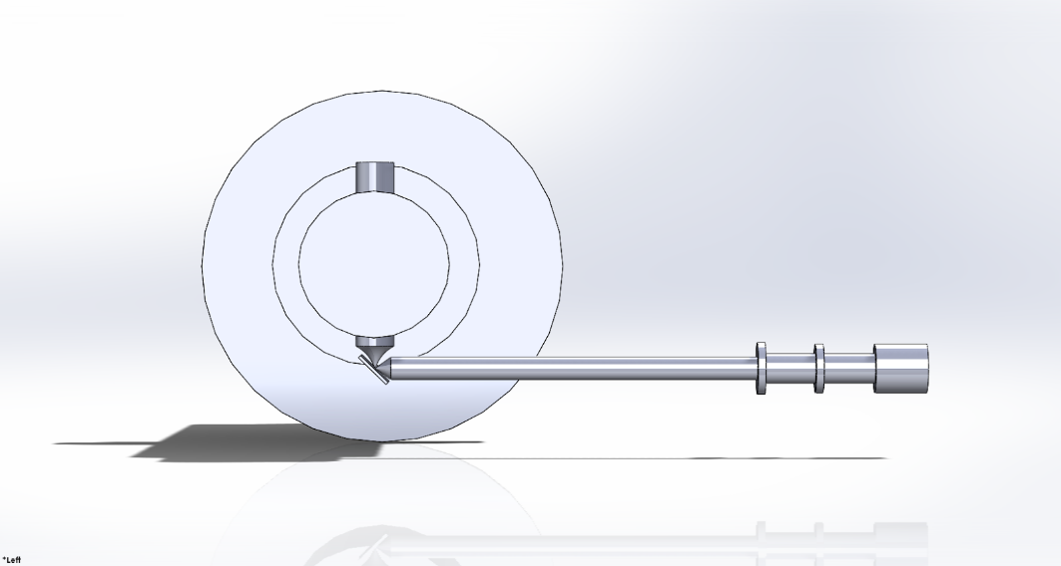

Figure 11: Left Side View of Sample, Ion Gun, and TOF

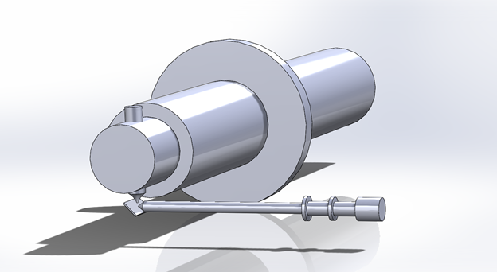

Figure 12: Isometric View of Sample, Ion Gun, and TOF

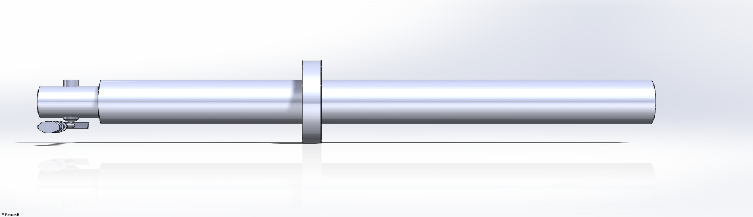

Figure 13: Front View of Sample, Ion Gun, and TOF

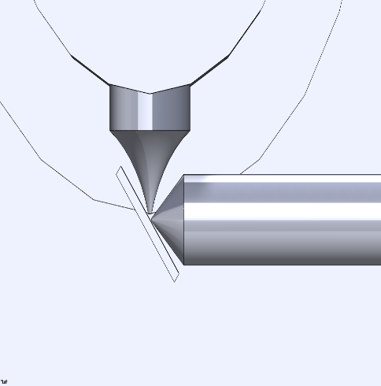

Figure 14: Zoomed in Perspective of Ion Gun and TOF Geometric Relation to Sample

MATLAB can be used to calculate ion detection rates from voltage, beam intensity, and geometries [11]. These values still need to be determined so that theoretical detection of ions can be simulated from the resulting geometries in Figs. 11 through 14. Specifications from manufacturers still need to be obtained. The team expects more detail and cooperation from manufacturers when parts have been ordered and paid for.

### Ion Gun Placement

The ion gun physical attachment has been determined to be placed on the endcap of the chamber. Due to high tolerances as well as possible reconfigurations. If the ion gun mounting flange was part of the welded chamber future adjustments would be difficult and expensive, potentially with a new chamber needed. Since the gun will be mounted to the cap, just a new cap will be needed resulting in more flexibility and reduced cost.

### Pumping Time Calculation

UHV vessels are used in different disciplines of science to analyze phenomenon happening at a molecular level. UHV is at a pressure of 10-6to 10-8Torr [6] and can take days to weeks to achieve based upon the geometry and other processes that are used to reached this level of vacuum. The volume of the vessel and the material of the vessel are important variables in the evacuation time of UHV vessels. For this analysis, a stainless steel and aluminum cylindrical (Fig. 15) vessel with a range of volumes will be used along with a HiCube 80 Eco turbopump (Fig. 16).

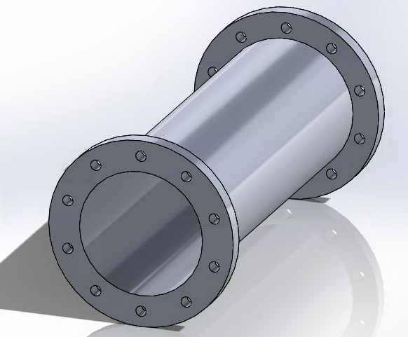 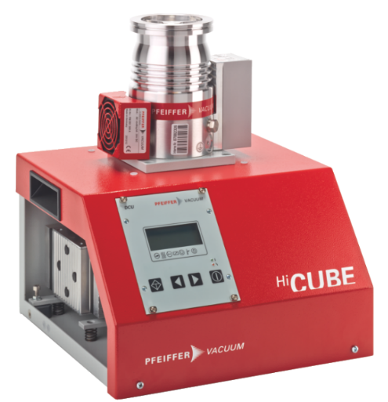

Figure 15: Cylindrical Vessel Figure 16: HiCube Eco 80 Turbopump

The evacuation time for the vessel shown in Figure 15 was calculated over a range of volumes using two different materials. The results for the range of volume and two different materials of the vessel can be seen in Fig. 17 through 20.

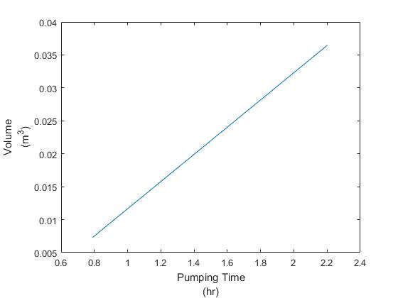

Figure 17: Pumping Time at 7.510-6Torr for Stainless Steel

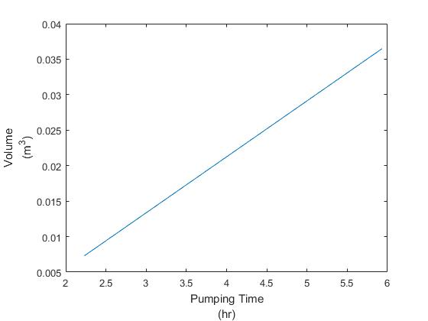

Figure 18: Pumping Time at 7.510-6Torr for Aluminum

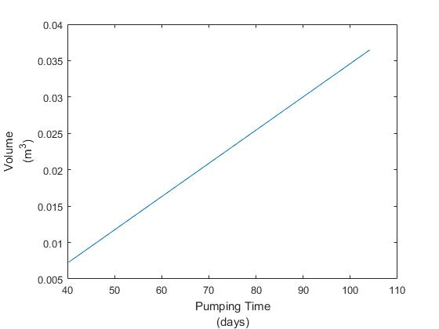

Figure 19: Pumping Time at 7.510-7Torr for Stainless Steel

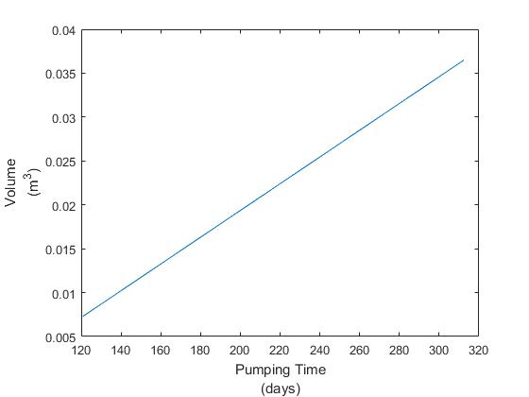

Figure 20: Pumping Time at7.510-7Torr for Aluminum

The pumping time and the volume of the vessel have a linear relationship saying that as the volume of the vessel increases the pumping time also increases proportionally. It can also be seen that as the working pressure of the UHV system begins to pass 7.510-6Torr the time for evacuation increases to units of days to months. This is especially shown in figure 7 for aluminum at a working pressure of 7.510-7Torr.

### Ion Gun and Extractor Alignment

For a SIMS instrument to output a spectrum characterizing the chemical content of a target surface, the primary ion source must be aligned to the secondary ion extractor within 50 micrometers (microns) [Dr. Michael V. Lee]. During the ablation, the secondary ions are diffuse and are mixed with primary ions as well as sub surface ions. The fine alignment allows the extractor to accelerate mostly surface secondary ions allowing analytical chemistry analysis. The marketplace offers solutions to fine alignment tolerances. Kurt. J. Lesker Company offers the PA35-H adjustable bellows with adjustability of +/-5mm axially and +/-3 degrees at a price of $1,423 [7]. Due to the budget constraints and problem statement of simply getting a spectrum, a cheaper alternative is desirable [12]. Through a finite element analysis, it has been determined that compressing a CF flange copper gasket using asymmetrical torque of clamping hardware will allow the primary ion impact location sufficient adjustability to meet the 50-micrometer alignment tolerance. A cross section of the CF flange can be seen in Fig. 21.

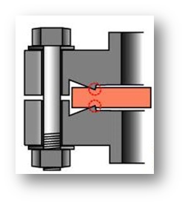

Figure 21: Cross section of a CF flange with copper gasket that is deformed to create a seal [13]

# PENDING DESIGN SELECTED

A traditionally fabricated custom engineered vacuum chamber in conjunction with the Non-Sequitur 1403 TOF/SIMS ion gun [2] and Jordan TOF Products Linear TOF detector [14] is proposed.  The specific chamber design has been delayed due to prototyping of investment mold casting and confirming geometry/dimensions of the purchased equipment and their relationship.  Now that the purchased equipment is specified the remaining design is properly constrained.  Since the lead time associated with a custom fabricated chamber is unknown and assumed to be long, the chamber will be designed and quoted over winter break.

# REFERENCES

[1] "Secondary Ion Mass Spectrometer (SIMS)", *Techniques*, 2016. [Online]. Available: http://serc.carleton.edu/research_education/geochemsheets/techniques/SIMS.html.

[2] "Nonsequitur Technologies: Model 1403", *nonsequitur-ion-gun*, 2016. [Online]. Available: http://nonsequitur-ion-gun.com/Model_1403.html.

[3] R. Bahamonde, "Secondary Ion Mass Spectrometry Labs at Arizona State University", *Sims.asu.edu*, 2016. [Online]. Available: http://sims.asu.edu/.

[4] "Materials Science and Engineering | Materials Engineering | News", *AZoM.com*, 2016. [Online]. Available: http://www.azom.com/.

[5] "Time-of-flight mass spectrometry," in Wikipedia, Wikimedia Foundation, 2016. [Online]. Available: https://en.wikipedia.org/wiki/Time-of-flight_mass_spectrometry.

[6] A. Benninghoven, R. J. Colton, D. S. Simons, and H. W. Werner, Secondary ion mass Spectrometry SIMS V: Proceedings of the fifth. Springer Science & Business Media, 2012. [Online]. Available: https://goo.gl/rw2OVo.

[7] I. plate and Fujifilm, "Photostimulated luminescence," in Wikipedia, Wikimedia Foundation, 2016. [Online]. Available: https://en.wikipedia.org/wiki/Photostimulated_luminescence.

[8] K. J, "Vacuum science is our business," 1996. [Online]. Available: [http://www.lesker.com/newweb/chambers/std_sphericalchamber.cf](http://www.lesker.com/newweb/chambers/std_sphericalchamber.cfm)m.

[9] "Kurt J. Lesker Company | Y, XY, & XYZ Motion | Vacuum Science Is Our Business", *Lesker.com*, 2016. [Online]. Available: http://www.lesker.com/newweb/sample_manipulation/y-xy-xyz-motion-menu.cfm.

[10] P. Vacuum, "Bake-out", *Pfeiffer-vacuum.com*, 2016. [Online]. Available: https://www.pfeiffer-vacuum.com/en/know-how/introduction-to-vacuum-technology/influences-in-real-vacuum-systems/bake-out/.

[11]A. Pivovarov, F. Stevie, D. Griffis and G. Guryanov, "Optimization of secondary ion mass spectrometry detection limit for N in SiC", *Journal of Vacuum Science & Technology A: Vacuum, Surfaces, and Films*, vol. 21, no. 5, p. 1649, 2003.

[12] "Kurt J. Lesker Company | Port Aligners | Vacuum Science Is Our Business", *Lesker.com*, 2016. [Online]. Available: http://www.lesker.com/newweb/sample_manipulation/adjusters_portaligner.cfm?pgid=0.

[13] "Materials Science and Engineering | Materials Engineering | News", *AZoM.com*, 2016. [Online]. Available: http://www.azom.com/.

[14] "Time of Flight Mass Spectrometer Components from Jordan TOF Products, Inc.", *Rmjordan.com*, 2016. [Online]. Available: http://www.rmjordan.com/.

# APPENDICES

Table 3: Customer Needs (CN) & Engineering Requirements

|  |  |  |  |  |  |  |  |  |  |  |  |
| --- | --- | --- | --- | --- | --- | --- | --- | --- | --- | --- | --- |
| **Customer Requirements** | **Weight  (1-10)** | **Engineering Requirements** | **Tolerance (+/-) (value)** | **Testing Procedure** | **Design Links** | **Correlation to CN  (1-5)** | **Absolute Technical  Importance (values)** | **Relative  Technical  Importance** | **Calc. Weight** | **Weight** | |
| Compact | 9 | Spherical chamber with diameter of about 6 inches | 0.5 in. | Measuring Diameter | Limiting the volume of the volume of the F2:F19chamber will reduce the amount of time it takes to pump | 4 | 36 | 4 | 0.09 | 0.06 | |
| Quick Preparation | 4 | Pumping to 10^-6 torr takes less than 30 days | 7 days | Timing the process | Shortening the time it takes to pump will increase efficiency | 5 | 20 | 10 | 0.04 | 0.09 | |
| Vapor Removal System | 4 | Chamber can withstand at least 300°c | 50°C | Measuring temperature and inspecting chamber | Will assure that the chamber is not compromised at high temps. | 4 | 16 | 11 | 0.04 | 0.05 | |
| Alignment for Material | 7 | Effective means of z-axis translation |  | Seeing effectiveness and ease to use | Will allow the spot areas to be aligned | 4 | 28 | 9 | 0.07 | 0.05 | |
| Multiple Samples Usable | 2 | Effective means of x-y plane translation |  | Seeing effectiveness and ease to use | Will allow us to change materials without having to re-pump the vacuum | 3 | 6 | 16 | 0.02 | 0.01 | |
| Securing Material | 7 | Reliable and easy to use securing apparatus |  | Material does not come loose and is easy to use | Will assure that the sample does not move | 5 | 30 | 7 | 0.06 | 0.05 | |
| Ability to Add Future Accessories | 3 | At least 4 ports | 1 port | Counting | Will allow use of other mechanisms in the UHV chamber | 4 | 20 | 12 | 0.05 | 0.04 | |
| Easy to Add Accessories | 2 | Mounting ports compatible with variety of accessories |  | Attach and Remove accessories | Will ensure instruments are not likely to be damaged during installation | 4 | 8 | 15 | 0.02 | 0.04 | |
| Precise and Accurate | 7 | Ability to target w/in tolerance | 20 µm | Measuring spot size | Will assure that we are collecting protons of the material | 5 | 35 | 5 | 0.07 | 0.1 | |
| Safe to Use | 10 | Shielding for all apparatuses |  | Measure Radiation | Needed to ensure no one is exposed radiation is not | 4 | 40 | 3 | 0.10 | 0.09 | |
| Table 2: Customer Needs (CN) & Engineering Requirements Continued… | | | | | | | | | | |  | |
| **Customer Requirements** | **Weight  (1-10)** | **Engineering requirements** | **Tolerance (+/-) (value)** | **Testing Procedure** | **Design Links** | **Correlation to CN  (1- 5)** | **Absolute Technical  Importance (values)** | **Relative  Technical  Importance** | **Calc. Weight** | **Weight** | |
| Moveable by Personnel | 2 | Under 80 lbs. | 15 lbs. | Weigh on industrial scale | Irrelevant to use but more practical for installation | 4 | 8 | 14 | 0.02 | 0.02 | |
| System Grounding | 8 | Securing the chamber and base to workbench |  | Testing to see that the system is firmly mounted | A system that is not stable can introduce unexpected failures | 4 | 32 | 6 | 0.08 | 0.06 | |
| Focusing of Atoms | 7 | The ability to focus atoms into the TOF |  | Measuring quantity of atoms collected in the TOF | Focusing atoms into TOF will give us a better reading on the material | 5 | 30 | 8 | 0.06 | 0.07 | |
| Proof of Functionality | 10 | Show that we are getting atoms to the entrance of the TOF |  | Checking the Phosphorus sheet for proof of receiving atoms | Proof that we are receiving atoms @ end TOF shows that our system is successful even if data is not precise | 5 | 50 | 1 | 0.10 | 0.1 | |
| Price | 10 | Manufacturing a chamber for under $3000 | $3,000 | Calculating the cost of the Chamber | We have a certain budget that we cannot exceed | 5 | 50 | 2 | 0.10 | 0.09 | |
| Viewport or Camera | 5 | Able to look though viewport without eyewear |  | Observe after use if any energy or material can be harmful | Will allow for observation at the surface of the material | 2 | 10 | 13 | 0.05 | 0.03 | |
| Innovative | 2 | Innovative design for sample plate |  | Does it simplify or overcomplicate | May make the system easier to use or more efficient | 3 | 6 | 17 | 0.02 | 0.03 | |
| 1 | Innovative design for vacuum entry |  | Does it simplify or overcomplicate | May make the system easier to use or more efficient | 3 | 3 | 18 | 0.01 | 0.02 | |
| Absolute Technical Importance | | | 430 |